BUSHFIRE SAFETY POLICY
Lake Baroon Catchment Care Group Inc
PO Box 567, Maleny Qld, 4552
Tel: 07 5494 3775
Email: info@lbccg.org.au

Policy Number | 023 | Responsible person | Chair
Version | 2020 | Approved by Committee on
Drafted by | Manager | Scheduled review date | As required

Introduction

Lake Baroon Catchment Care Group and staff are committed to ensuring a safe working environment for all its staff, volunteers, contractors and visitors. As a consequence of this, Lake Baroon Catchment Care Group encourages all its staff members to be aware of the fire risk during bushfire season in the field and at the office.

Purpose

The purpose of this policy is to ensure staff members and volunteers are aware of their responsibilities as employees/volunteers of Lake Baroon Catchment Care Group, and are committed to ensuring the safety of staff, volunteers, contractors and visitors. In fulfilling this responsibility, all members of Lake Baroon Catchment Care Group have a duty to stay informed of the bushfire risk status to ensure they, so far as practicable, act according to current recommendations.

Policy

Lake Baroon Catchment Care Group recognises its moral and legal responsibilities to provide a safe work environment for its employees, volunteers, contractors and visitors.

Lake Baroon Catchment Care Group is committed to:
- Ensuring no staff/volunteers/contractors should be placed at risk or allowed to remain at risk during a bushfire or when there is a high fire danger.
- Procedures are aimed at removing teams from contact with bushfires.
- Pre-bushfire season preparation is essential
- Managers will stay informed of current bushfire warnings and reports

Responsibilities

All Lake Baroon Catchment Care Group Project Managers are responsible and accountable for providing a safe workplace for other staff, volunteers and contractors.
In particular, the Lake Baroon Catchment Care Group will ensure:

That protocols are discussed prior to the bushfire season.
- Bushfire risk status
- When not to attend the office/project site
- When and how to contact staff/volunteers/contractors
- Where to meet in an emergency
- Which documents are irreplaceable and should be removed from the office or copied.
- Bushfire risk is on the Site risk assessment form and must be assessed daily, it is also comprehensively covered on the LBCCG Safety Management System document.

That adequate preparations are made prior to bushfire season.
- Identify the most reliable sites to receive current local bushfire warnings and reports
- Ensure a review of local emergency response procedures.
- Brief or train staff to understand that during the bushfire season the possibility of a bushfire must be included in every project site risk assessment, and an appropriate evacuation plan developed and communicated to all participants
- Ensure that all staff or project managers are familiar with, and understand, the emergency response and communication procedures.
- Ensure that the office site is well maintained, as far as is possible, to reduce fire risk.

Procedures during the Bushfire season
- That bushfire risk is discussed with project partners, and the outcomes of discussion are communicated to Project Managers. Access to and egress from the project site/ office must be considered.
- Monitor daily news and Emergency Service reports and note Fire Danger Ratings for the region.
- Advise the Group when there is a bushfire alert.
- Ensure there is a mechanism for making immediate contact with all staff/volunteers and contractors.
- Include bushfire risk on all project risk assessments
- Discuss an evacuation plan.

Procedures during periods of High Fire Danger
- Stand down or cancel project activities and attendance at the office on days of Catastrophic (code red) Fire Danger
- Do not work or walk in forest, bushland or grassland or other high fire danger areas on days of Severe or Extreme Fire Danger.
- No on-ground works on days of Severe or Extreme Fire Danger.
- No driving vehicles off-road on days of Severe or Extreme Fire Danger.
- Identify the “place of last resort” for each worksite. All staff, volunteers and contractors are to be aware that finishing the project is never a higher priority than the safety of people.
- Recognise the major bushfire risk factors; high temperature, high winds, low humidity and abundant dry fuel.

If Fire threatens the office or access to the office
- Evacuate the office
- First meeting point, if safe to do so, is at Maleny Showgrounds
- If North Maleny Road is blocked go to Lake Baroon Dam
- As soon as is possible message all other staff members to let them know the office has been evacuated, your location and ascertain their location.
- If the fire is close do not take anything with you, leave immediately.
All files on Z drive are backed up weekly, ensure your documents are regularly backed up to Z drive.

Understand the Fire Danger Ratings
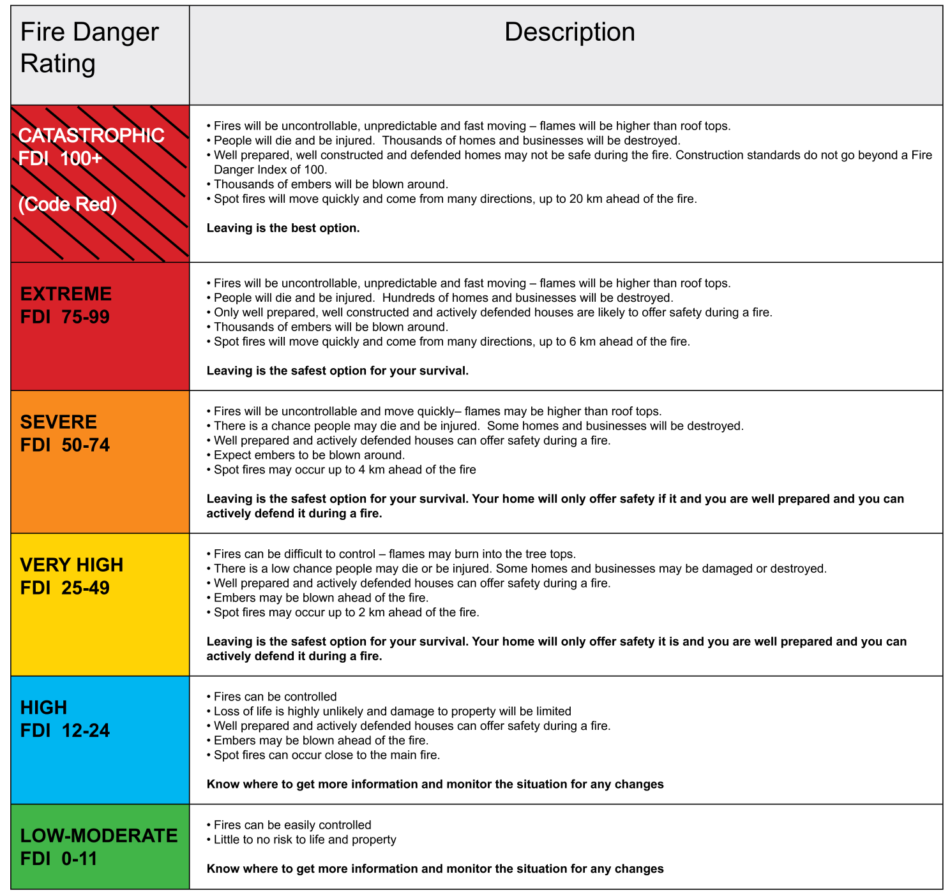

Review of Policy

The Bushfire Safety policy will be reviewed annually by the person nominated by the Management Committee in consultation with the Manager. The review will involve assessing the effectiveness of the policy and program by such means as:
- monitoring the effectiveness of policies and procedures

Dissemination of Policy
The Bushfire Safety Policy and related procedures shall be displayed in the workplace and all employees and volunteers will be provided with a copy through their supervisor. New employees will be provided with a copy of the policy as part of their induction.
The Policy will be reviewed on an annual basis to ensure it remains compliant with the relevant State legislation.

Related Documents
LBCCG Safety Management System Manual (6.8)

Useful Information

Queensland Rural Fire Service website: https://www.ruralfire.qld.gov.au

Link to Current Bushfires: https://www.ruralfire.qld.gov.au/map/Pages/default.aspx

Bureau of Meteorology website: http://www.bom.gov.au/australia/meteye/

ABC Sunshine Coast radio website: https://www.abc.net.au/radio/sunshine/

Bushfire Safety Plan
KNOW
Community Safe Meeting points: Maleny Showgrounds or Maleny State High School.
If evacuating from the Office, last resort, meeting point at Lake Baroon carpark
- Rural Fire Brigade contact: 07 5420 7517
- Maleny and District Fire Warden: 0428 123 302
- The Current bushfire danger rating

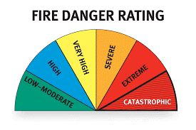

PREPARE
- Up to date contact list for staff and volunteers – copy of contacts to be held securely on website
- Review local emergency response procedures
- Tidy yard, gutters etc around the office
- Ensure all documents are backed up to Z drive and a portable hard drive copy has been made
- Take Anything irreplaceable?
DISCUSS
Know the current bushfire risk status
- When not to attend the office/project site
- When to contact staff/volunteers/contractors
- Where to meet in an emergency
- What to take from the office – what is irreplaceable?
- Fire risk is included on the Site Risk assessment form and must be assessed daily. It is also covered on the WH&S documents

KEEP INFORMED
- Receive notifications on: Twitter: @QldFES
Facebook: QLD Fire and Emergency Services QFES and ABC Sunshine Coast
Radio: ABC Sunshine Coast (listen online on the ABC listen app or 90.3 FM or 95.3 FM)
Website: www.ruralfire.qld.gov.au
App: Fires Near Me (this is a NSW app but states that it covers all of Australia)

